UET PEShawar
Civil Department
Editors
Peshawar, Pakistan, March 27-29, 2019
Construction Cost Estimation
Using Monte Carlo Method
Syed Haseeb Shah
University of Engineering & Technology
Peshawar, Pakistan
Author.18PWCIV4991@uetpeshawar.edu.pk
web-page: http://ewgdssbelgrade2015.wordpress.com/
ABSTRACT
Monte Carlo methods are generalized class of computational algorithms that depends on random data to simulate and evaluate numerical results to a problem. Unlike traditional simulation methods no specific formulas needs to be defined for this model to work. The model works by simulating the problem specified. Instead of finding sophisticated formulas to solve a problem, the problem is describe programmatically as a process. Then the process is repeated over thousands to millions of times and the output data is observed. On the basis of which decisions are made. The real benefit of this method is that instead of thinking in terms of the lowest cost and highest cost of a project a distribution is obtained. This probability distribution tells us about the safe cost estimation range.
Traditional techniques in cost estimation returns the min, max and average cost of a project.
Keywords: Short Paper, Monte Carlo, Building Cost Estimation

INTRODUCTION
It is expected that authors will submit carefully written and proofread material. Spelling and grammatical errors, as well as language usage problems, are not acceptable. There is no strict limitation to the number of pages, but it is suggested that the short paper length should not exceed 6 A4 pages.
Papers should clearly describe the background of the subject, the authors' work, including the methods used, as well as concluding discussion on the importance of the work. Papers are to be prepared in English (British or American). Technical terms should be explained unless they may be considered to be known to the broader research community. Acronyms should be written out at their first appearance.

Fonts
Papers should use 12-point Times New Roman font. The styles available are bold, italic and underlined. It is recommended that text in figures is not smaller than 10-point font size.

Tables and Figures
Figure captions and table headings should be sufficient to explain the figure or table without needing to refer to the text. Figures and tables not cited in the text should not be presented in the paper. The following are example for Table 1 and Figure 1.

Table 1: Title of Example Table
Header | X | Improved
(Flow control valves) Air operated valves | 4 | Yes
Check valves | 2 | Yes
Line discharge check valves | 4 | Yes
Pump discharge check valves | 3 | Yes
Motor driven pumps | 2 | Yes
Motor driven pumps | 2 | No

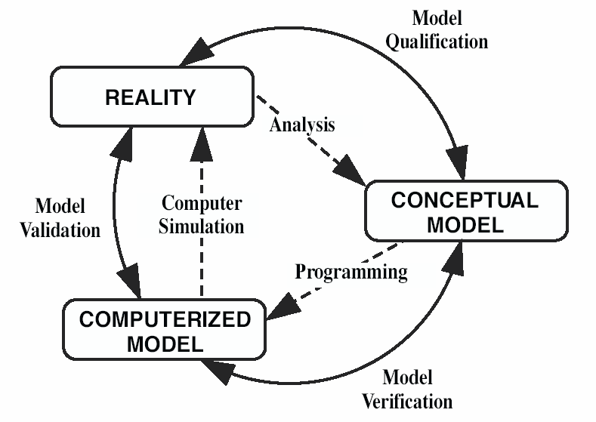
Figure 1: Verification, Validation and Qualification

Tables and figures should be placed close after their first reference in the text. All figures and tables should be numbered. Table headings should be centered above the tables. Figure captions should be centered below the figures.

SECTIONS

Main sections
The titles of the main sections should be placed left and written with uppercase bold Times-Roman 12 point font. In order to avoid orphans on the text, make sure that at least three lines of text are typed after the section title and before any page break. The graphical appearance of the publication will profit from your care.

Subsections
The subsection titles should be written placed left, with a bold Times-Roman font, 12 point. Only the first letter of the title is uppercase, being all others lowercase. In order to avoid orphans on the text make sure that at least three lines of text are typed after the subsection title and before any page break.

CONCLUSIONS
Conclusions should state concisely the most important propositions of the paper as well as the author’s views of the implications of the obtained results.

REFERENCES
References should be placed at the end using 12 point Times-Roman and cited as [1] or [1, 2]. The references should be listed in the same order as cited in the text. See examples below.

- K.N. Flam, S.B. Rem, G.A. Tim, A. Moss, A. Afzu, “Example 1 of Reference for the ICDSST 2015 Short Paper Template”, EPRI TR-100382, Electric Power Research Institute, CA., USA, 2002.
- N. Watson, “Example 2 of Reference for the ICDSST 2015 Short Paper Template”, Springer-Verlag, Berlin, Germany, 2010.

